Safe System Assessment (Full)
Enter project name
Version: Click here to enter version number.
Date: Click here to enter a date.

Executive Summary
Provide a high level summary of the assessment, including the SSA Matrix scores and suggested treatments / design changes.
E.g. A full Safe System Assessment (SSA) has been conducted on xxxxxxx project. Existing conditions and two design options were assessed. The SSA Matrix scores are shown in the table below.

Option | Score
Existing conditions | xx / 448
Design Option 1 | xx / 448
Design Option 2 | xx / 448

Summarise the conclusions of the assessment, highlighting the crash types that are the main contributors to the score. List the suggested treatments / design changes that should be considered to improve alignment with the Safe System approach.

Table of Contents
Executive Summary 1
Figures 3
Tables 3
1. Introduction to the Safe System 4
1.1. Safe System Pillars 4
1.2. Safe System Impact Speeds 4
2. Safe System Assessment Process 5
3. Assessment Details 5
3.1. Type of Assessment 5
3.2. Assessment Team 5
3.3. Meetings and Site Inspections 6
4. Project Description 6
4.1. Project Background and Objective 6
4.2. Existing Conditions and Context 6
4.3. Proposed Works 7
5. Assessment of Project Design Options 7
5.1. Assessment Summary 7
5.2. Safe System Assessment Matrices 9
6. Treatments to Improve Safe System Alignment 10
7. Additional Safe System Components 10
8. Conclusions 11
Appendix A 12

Figures
Figure 1: Safe System Pillars 4
Figure 2: Safe System Impact Speeds 5
Figure 3: SSA Scores for Crash Types 8

Tables
Table 1: Project Background 6
Table 2: Existing Conditions and Context 7
Table 3: SSA Matrix Scores for the Project 7
Table 4: SSA Matrix – Insert option e.g. “Existing Conditions”, “Design Option 1” etc. Add and complete a table for each option. Refer to VicRoads Safe System Assessment Guidelines for guidance on scoring. 9
Table 5: Primary Treatments 10
Table 6: Supporting Treatments 10
Table 7: Other Safe System Components 10

- Introduction to the Safe System
  - Safe System Pillars
The Safe System approach seeks to ensure that no road user is subjected to kinetic energy exchange in a crash that will result in death or serious injury. There is a shared responsibility for safe travel outcomes between system designers (road authorities, vehicle manufactures, road designers etc.) and road users. There are four Safe System pillars: safer vehicles, safer speeds, safer roads and safer road users. Post-crash response is another element that is often recognised as the fifth pillar. All parts of the system must be considered and strengthened so that road safety outcomes are maximised and to ensure that road users are adequately protected even if one part fails.
Safe System Assessment (SSA) is concerned mainly with the safer roads and safer speeds pillars. A SSA is used to examine road project proposals and aims to identify infrastructure and speed related factors that are likely to contribute to a higher risk of fatal and serious injury (FSI) crashes. It also seeks to identify design or scope changes that will improve the alignment of the project with Safe System principles.
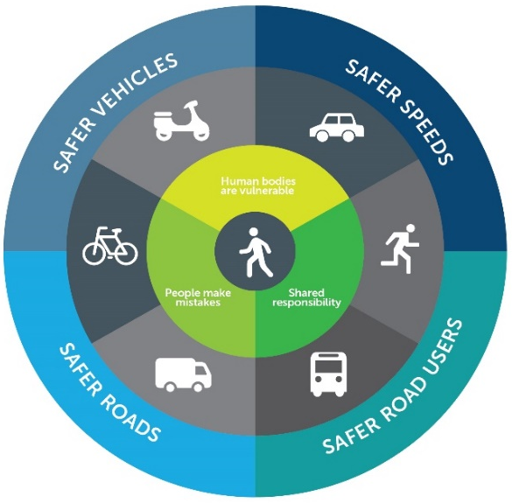
Figure 1: Safe System Pillars

  - Safe System Impact Speeds
The impact speed in a collision is a significant factor that affects the probability of a person being killed or seriously injured in a crash. Safe System impact speeds are speeds below which the chances of survival are high and the likelihood of serious injury is low.
Figure 2 is a guide to Safe System impact speeds for common crash types. It should be noted that the angle of impact of a collision is also a factor that affects the severity of a crash. As far as is practically possible, infrastructure should be designed and travel speeds managed so that the impact speeds when a crash occurs are below the thresholds show in Figure 2.

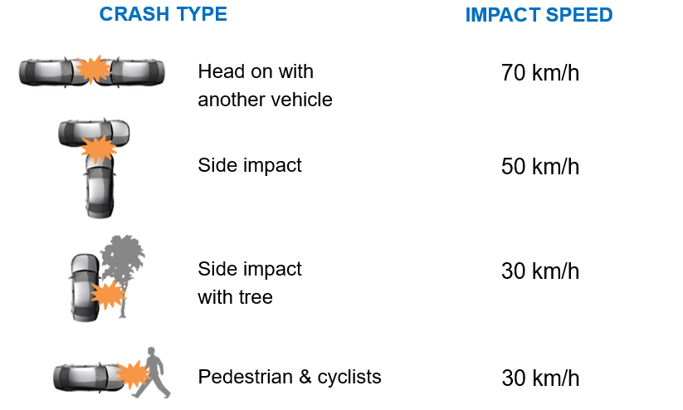

Figure 2: Safe System Impact Speeds

- Safe System Assessment Process
The Safe System Assessment process is based on Austroads Safe System Assessment Framework (Austroads 2016, Research Report AP-R509-16, Safe System Assessment Framework) and VicRoads Safe System Assessment Guidelines.
Steps in the process include:
- Deciding on the type of assessment (full or rapid)
- Selecting an appropriate team to conduct the assessment
- Understanding the project background, context and objectives
- Collation of information and data for both existing and future conditions
- Inspection of the site
- Conducting the assessment of existing conditions and each project design option using the SSA Matrix
- Consideration of the additional Safe System components; road users, vehicles and post-cash care
- Review of the SSA Matrix scores and development of suggested changes to improve alignment with Safe System principles
- Reporting
- Review of suggested design and scope changes
- Amendment of project scope and design to incorporate the accepted changes.
- Assessment Details
  - Type of Assessment
State that this is a Full SSA that has been conducted in accordance with VicRoads Safe System Assessment Guidelines and Austroads Safe System Assessment Framework (Austroads Research Report AP-R509-16). Include any additional information that may be relevant to the decision to undertake a Full SSA.
  - Assessment Team
List the members of the SSA Team, their titles, department and organisation. Identify any members that are associated with the project being assessed and are therefore not independant.
  - Meetings and Site Inspections
List all meetings (e.g. commencement meeting), site inspections and workshops held, with dates. Include the times of site inspections.
- Project Description
  - Project Background and Objective
Provide sufficient detail about the project background and the objectives to demonstrate an understanding of why the project is being developed. Where appropriate, make reference to the Investment Logic Map and Benefit Management plan for problem definition and the objectives of the project. Complete Table 1. Describe the limits of the works and, if appropriate, include a map showing the location of the project.
Prompts | Comments
What is the reason for the project? Is there specific crash type risk? Is it addressing specific issues such as poor speed limit compliance, road access, congestion, future traffic growth, freight movement, amenity concerns from the community, maintenance/asset renewal, etc.
Table 1: Project Background
  - Existing Conditions and Context
Provide a detailed description of existing conditions. Describe the function of the road, referring to Movement and Place where possible. Is the road part of a freight route of bicycle route? Refer to network maps for heavy vehicles – https://www.vicroads.vic.gov.au/business-and-industry/heavy-vehicle-industry/heavy-vehicle-map-networks-in-victoria . Refer to any available data on vehicle speeds and information regarding compliance with speed limits. Note if the presence of heavy vehicles increases the risk of particular crash types e.g. run-off-road, intersection and vulnerable users. Complete Table 2 as a summary. Include photos in an Appendix as necessary.
Prompts | Comments
What is the function of the road? Consider location, roadside land use, area type, speed limit, intersection type, presence of parking, public transport services and vehicle flows. What traffic features exist nearby (e.g. upstream and downstream)? What alternative routes exist?
What is the speed environment? What is the current speed limit? Has it changed recently? Is it similar to other roads of this type? How does it compare to Safe System speeds? What is the acceptability of lowering the speed limit at this location?
What road users are present? Consider the presence of elderly pedestrians, school children and cyclists. Also note what facilities are available to vulnerable road users (e.g. signalised crossings, bicycle lanes, school speed limits, etc.)
What is the vehicle composition? Consider the presence of heavy vehicles (and what type), motorcyclists and other vehicles using the roadway.
Table 2: Existing Conditions and Context
  - Proposed Works
Provide a description of the proposed works. Identify and describe each project design option that is being assessed – use diagrams / illustrations as necessary (either here or in an appendix). Provide a listing of the design drawings that were assessed – including drawing and issue numbers.
- Assessment of Project Design Options
  - Assessment Summary
The Safe System Assessment Matrix scores for the existing conditions and the proposed design options are shown in Table 3. The scores for each crash type are shown in Figure 3. The detailed assessments are presented in Section 5.2.
Insert scores into Table 3 and edit Figure 3. If the project has been divided into two or more segments, provide details and the SSA Matrix scores for each segment. Provide a discussion of the results and conclusions. Compare the project options with existing conditions. In particular, highlight the crash types that present the highest risk and explain why. Identify the areas where there are opportunities to improve alignment with the Safe System.

Table 3: SSA Matrix Scores for the Project
Option | Score
Existing conditions | xx / 448
Design Option 1 | xx / 448
Design Option 2 | xx / 448

Figure 3: SSA Scores for Crash Types

  - Safe System Assessment Matrices
Table 4: SSA Matrix – Insert option e.g. “Existing Conditions”, “Design Option 1” etc. Add and complete a table for each option. Refer to VicRoads Safe System Assessment Guidelines for guidance on scoring.
 | Run-off road | Head-on | Intersection | Other | Pedestrian | Cyclist | Motorcyclists
Exposure Comments:
Exposure Score: | /4 | /4 | /4 | /4 | /4 | /4 | /4
Likelihood Comments: | Factors that increase the likelihood include:  Factors that decrease the likelihood include: | Factors that increase the likelihood include:  Factors that decrease the likelihood include: | Factors that increase the likelihood include:  Factors that decrease the likelihood include: | Factors that increase the likelihood include:  Factors that decrease the likelihood include: | Factors that increase the likelihood include:  Factors that decrease the likelihood include: | Factors that increase the likelihood include:  Factors that decrease the likelihood include: | Factors that increase the likelihood include:  Factors that decrease the likelihood include:
Likelihood Score: | /4 | /4 | /4 | /4 | /4 | /4 | /4
Severity Comments: | Factors that increase the likelihood include:  Factors that decrease the likelihood include: | Factors that increase the likelihood include:  Factors that decrease the likelihood include: | Factors that increase the likelihood include:  Factors that decrease the likelihood include: | Factors that increase the likelihood include:  Factors that decrease the likelihood include: | Factors that increase the likelihood include:  Factors that decrease the likelihood include: | Factors that increase the likelihood include:  Factors that decrease the likelihood include: | Factors that increase the likelihood include:  Factors that decrease the likelihood include:
Severity Score: | /4 | /4 | /4 | /4 | /4 | /4 | /4
Product  (multiply scores above for crash type) | /64 | /64 | /64 | /64 | /64 | /64 | /64
TOTAL |  |  |  |  |  |  | /448

- Treatments to Improve Safe System Alignment
Table 5 and Table 6 list treatments that will improve the Safe System alignment of the project.
Primary treatments are those measures that have the potential to eliminate or come close to eliminating the risk of fatal and serious injury (FSI) crashes.
Supporting treatments are effective in reducing the risk of FSI crashes but not to the extent of a primary treatment (i.e. there is a residual moderate or significant FSI crash risk). Implementation of a primary treatment should be given priority over a supporting treatment that may be targeting a similar crash risk.
Provide additional information to support the suggested treatments. For example, outline how the treatments will address the main areas of risk identified in the SSA Matrices.

Table 5: Primary Treatments
Treatments for consideration | Project response

Table 6: Supporting Treatments
Treatments for consideration | Project response

- Additional Safe System Components
As part of this SSA, consideration has been given to other components that comprise the Safe System i.e. road users, vehicles and post-crash care. Issues identified as relevant to this project are listed in Table 7.
Provide additional information / discussion of any issues that should be highlighted for consideration by the project team.
Table 7: Other Safe System Components
Pillar | Prompts | Comments / Issues
Road user | Are road users likely to be alert and compliant? Are there factors that might influence this?  What are the expected compliance and enforcement levels (alcohol / drugs, speed, road rules and driving hours)? What is the likelihood of driver fatigue? Can enforcement activities be conducted safely?  Are there special road users (e.g. entertainment precincts, elderly, children, on-road activities, motorcyclist route), distraction by environmental factors (e.g. commerce, tourism) or risk-taking behaviours?
Vehicle | What level of alignment is there with the ideal of safer vehicles?  Are there factors that may attract large numbers of unsafe vehicles? Is the percentage of heavy vehicles too high for the proposed / existing road design? Is this route used by recreational motorcyclists?  Are there resources in the area to detect non-roadworthy, overloaded or unregistered vehicles and thus remove them from the network? Can enforcement activities be undertaken safely?  Has vehicle breakdown been catered for?
Post-crash care | Are there issues that might influence safe and efficient post-crash care in the event of a severe injury (e.g. congestion, access, stopping space)?  Do emergency and medical services operate as efficiently as possible?  Are other road users and emergency response teams protected during a crash event? Are drivers provided the correct information to address travelling speeds on the approach and adjacent to the incident? Is there reliable information available via radio, VMS etc?  Is there provision for e-safety (i.e. safety systems based on modern information and communication technologies, C-ITS)?

- Conclusions
Outline the conclusions of the assessment. For example, are the proposals an improvement on existing conditions, what are the main crash risks, how well do each of the design options align with Safe System principles, which option is preferred and what changes could be made to the design / scope to further improve Safe System alignment.

Appendix A
Add appendices as required e.g. locality plan, site photos, crash data etc.

