Planning Scheme Policy - Geometric Road Design
Application of Movement and Place Framework
Practice Note #1 – Greenfield Development Example
_________________________________________________________________________________

About Movement and Place
The Movement and Place approach to planning and design recognises that roads facilitate the movement of people and goods by various modes of transport, as well as provide places for people and activity.
This approach builds on the functional road hierarchy by incorporating modal priority with modal mobility and acknowledges that streets and roads provide public spaces that often do more than facilitate movement and access. Streets also provide the space and places for recreation, social and cultural exchange and often economic activity. This approach aims to facilitate greater enjoyment of the surrounding environment and amenity, as well as opportunities for economic activity and vitality.
The Movement and Place approach focuses on the future aspirations for a street and provides a framework to establish a shared vision that can balance both the transport and land use activity objectives to guide the planning and design process to get improved outcomes.

Movement and Place Design Framework
The MRC Movement and Place Design Framework has four (4) key inputs which all contribute to determining the design outcome and final design form of the street. The four (4) key inputs which will need to be considered to inform the design process include:
1) Place value
2) Movement value
3) Modal priority assessment
4) Design environment
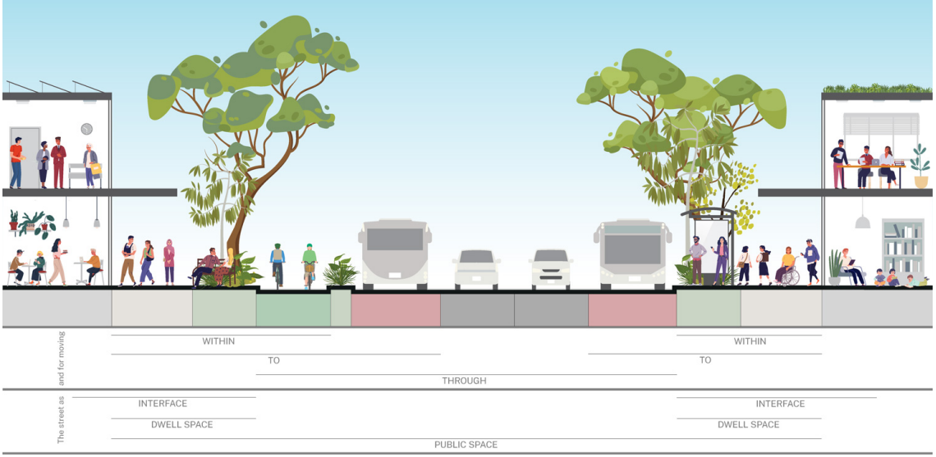
Source: Design of roads and streets (NSW)

Case Study #1: Hypothetical Bay - Greenfield Development

1. Project Details, Land Use & Street Network Layout
Hypothetical Bay is an urban and mixed-use development proposed on a 42.9Ha lot in the Mackay region.
The development proposed to provide low, medium and high-density residential allotments.
The development also includes several recreational parks and a local centre to provide for various community needs and services, as per below table.

No. Lots | Zoning Proposed
75 | Low-density residential
6 | Medium-density residential
4 | Recreational park
1 | High density residential
1 | Local centre

The layout includes seven (7) proposed new streets to provide mobility and access to, from and within the development.
The next steps will assess and identify movement and place design attributes for each street as summarised in the below table, discussed further in this guidance document.

Street | PX | Function | MX | Modal Priority | PX/MX Possible Typologies | Adopted Typology | Adopted Reserve Width (m)
Street A
Street B
Street C
Street D
Street E
Street F
Street G

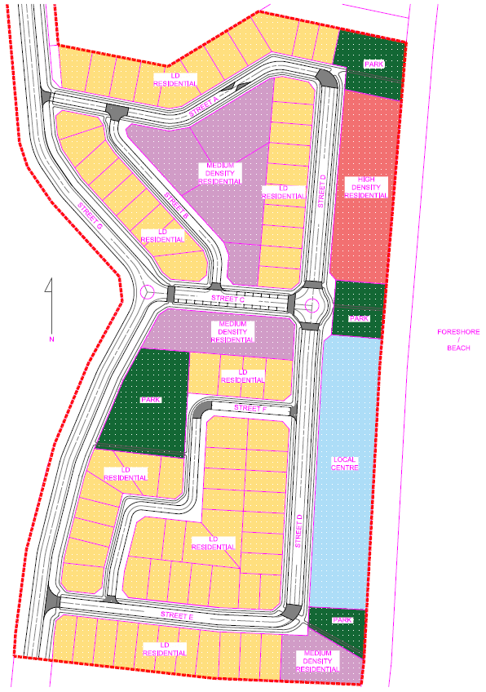
Fig 1 - Hypothetical Bay proposed land use layout

2. Determining the Place Value
The Place value is determined through a subjective assessment of the subdivision area and the anticipated level of activity within the street, how any use of the street interacts or is engaged with the adjoining land uses, and the scale of which the place is anticipated to attract.
This will primarily be based on the relative catchment of users and/or activity and its importance at either a local, neighbourhood, locality/suburb or at a regional scale.
All seven (7) streets are assessed below. Refer Figure 4-8 for typical urban place value characteristics.
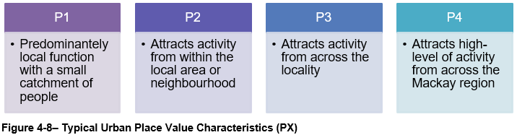
Street | PX |  | Function | MX | …
Street A | P1 | Mainly residential use – low activity. Potentially greater activity from medium density residential land. May need to consider adjacent land on Street D if this increases activity
Street B | P1 | Mainly residential use – low activity. Potentially greater activity from medium density residential land
Street C | P2 | Close proximity to local centre and foreshore, services medium density residential land – attracts activity from the local neighbourhood
Street D | P3 | High density and local centre frontages, directly on coastal foreshore – attracts activity from across the Mackay area
Street E | P1 | Mainly residential use – low activity. May need to consider adjacent land on Street D if this increases activity
Street F | P1 | Mainly residential use – low activity
Street G | P1 | Mainly residential use – low activity
Tips:
- A street with retail, restaurants, cafes along its frontage may attract people from a wider catchment and thus have a higher strategic significance for Place. A residential street with no other uses will attract people from a much smaller catchment and will have a lower strategic significance for Place. The Designer should also observe local themes and existing place aesthetics that already exist in the area of the project and decide whether these existing themes should also be integrated into the design.
- In greenfield and other situations where no design palette exists, the purpose of a place making approach is to build on the existing character and values of an area rather than contrive it. Accordingly, there will be instances where conditions of development approval will specifically require that design of infrastructure be consistent with Council’s adopted place making approach for the particular locality.
- If the road or street corridor is likely to have varying characteristics along its length, split into sections with like characteristics.

3. Determining the Movement Value
The Movement value is one of the key inputs into the determination of the MRC Movement and Place class. Movement value is scored between M1, though to M4 and is determined through a subjective assessment of the function of the link.
This assessment will need to consider all transport modes and their modal priority. This is based around its strategic importance in the network such as hierarchical function (Figure 3-2), the size or scale of the service catchment and the level of demand.
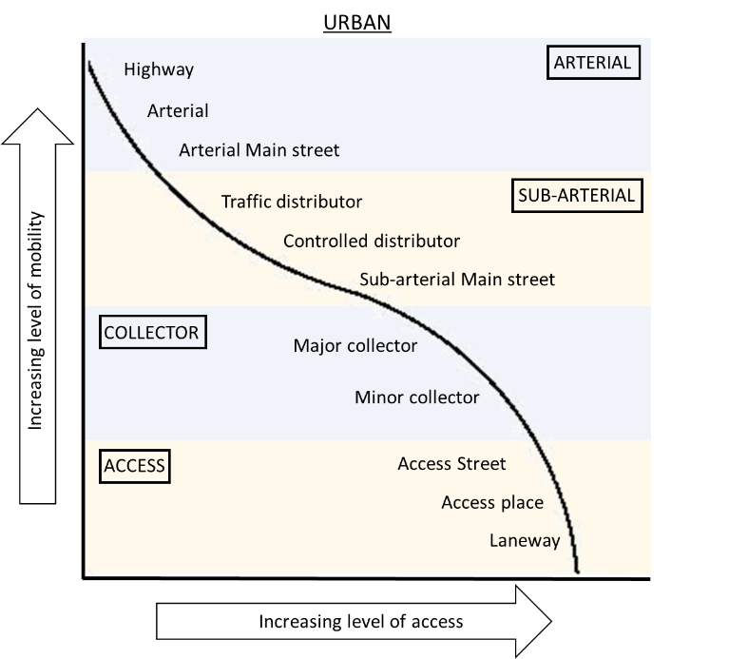
Figure 3-2 – MRC Road Hierarchy Classification - Urban

All seven (7) streets are initially assessed below. Refer Figure 4-10 for the typical movement value characteristics.
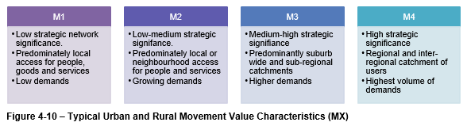

Street | PX | Function |  | MX |  | …
Street A | P1 | Access | Direct residential access | M1 | Mainly local access
Street B | P1 | Access | Mainly residential access function | M1 | Mainly local access
Street C | P2 | Access /  Collector | Direct access to properties, carries traffic with a trip end | M2 | Local-neighbour-hood access, high active transport demand, growing demands
Street D | P3 | Access /  Collector | Direct access to properties, carries traffic with a trip end, local/regional active transport movements | M2 | Local-neighbour-hood access for people and services, growing demands, high active transport
Street E | P1 | Access | Direct residential access | M1 | Mainly local access, consider proximity to Street D & G
Street F | P1 | Access | Direct residential access | M1 | Mainly local access
Street G | P1 | Collector | Carries traffic with a trip end to/from area | M2 | Local-neighbour-hood access, growing demands, possible bus route
Tips:
- MRC’s functional road hierarchy will be a useful starting point as the Road hierarchy classification will provide an indication of the importance of the link from a mobility and access perspective. Where Arterial roads have a high strategic significance, and Access streets have lower strategic significance. However, it is important to note that the alignment to the MRC functional road hierarchy will not strictly define the movement value as all modes and their priorities/ demands also need to be considered.

- Movement significance should be assessed for all modes such as people travelling on foot, by bike, by micro-transport (e.g., e-scooter), by bus, and movement of freight and services. Avoid basing movement values solely on traffic volumes – consider the criticality of the route within the network.
- Roads and streets perform an important access function, including access to residential properties, local services, public transport services, and distribution of freight. Regardless of the mode of travel, the priority for the Movement function is about moving people, goods and/or services safely, efficiently, and reliably.
- A road with a high pedestrian, cyclist or public transport use will have a higher movement significance than a road with local or less frequent movement.

- Movement assessment must consider all modes and their respective strategic modal networks. If a road or street is a high-level strategic route for any mode, that should be reflected in the movement significance.

4. Determining Modal Priorities
Modal priority is about understanding who uses the road link, for what purpose and by which transport mode and then having some relativity between modes. This enables planners, designers and decision makers to consider and develop options through the design process that will respond appropriately to each mode and better understand how certain design outcomes will benefit or impact specific modes.
In simple terms, when constrained for space – which transport mode is prioritised over another when allocating limited space for infrastructure or services?
A mode with a higher level of priority is considered more important than another with lower priority and therefore is afforded greater weight in the design process.
The modes defined in the MRC Movement and Place Design Framework that are required to be considered in the assessment include:
- People walking
- People cycling and using micro-mobility
- People using public transport
- Goods by road freight
- People in private vehicles
- Goods loading and servicing
- People parking private vehicles
- People parking bicycles and other micromobility.

Three (3) streets are assessed in detail, with the determined priorities published for all seven (7) streets. The MPFT is used to help illustrate and understand the adopted modal priorities.
Commentary: The MPFT modal priority tool has a numerical scale. The scale is arbitrary and used to aid the designer in determining modal priorities. Assessments are subjective, with the assessment process providing the designer the opportunity to review and understand modal priorities and form a basis to inform design decisions throughout the project.

STREET A
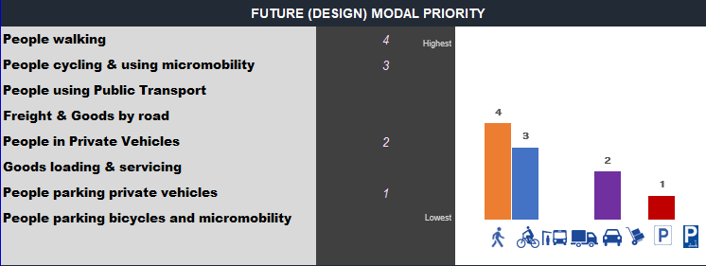
Walking is identified as the highest priority in Street A, followed by people cycling then private vehicles. Parking of private is vehicles is the lowest priority. Freight, goods and services and public transport do not feature and are not considered in this street.
Commentary: These assigned priorities indicate that active transport is a priority for this street, more-so than private vehicles. Also that on-street parking is of low priority.

STREET C
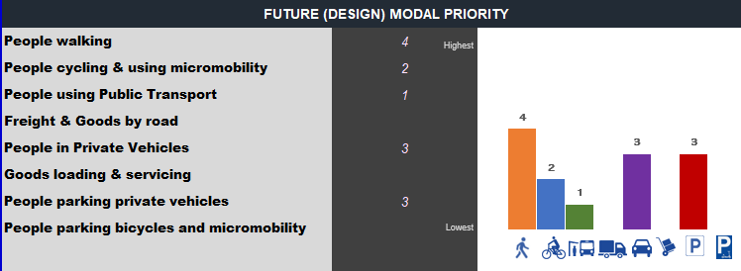
Walking is identified as the highest priority in Street C, followed by private vehicles and on-street parking. Cycling is then considered as the next priority, followed by public transport.
Commentary: These assigned priorities indicate that people walking is the highest priority, more-so than private vehicles as such would require suitable infrastructure for walking such as a shared path on one or even both sides of the street. On-street parking is recognised as a priority with high private vehicle demand anticipated, as such an on-street parking facility is likely needed. Cycling is not as high as a priority, however cyclists would be able to access the possible shared paths for people walking. Public transport is identified, as such bus through movement or a bus shelter (depending on a broader network review) would potentially need to be catered for.

STREET D
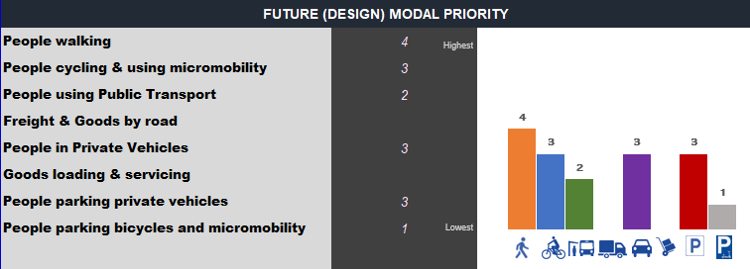
Walking is identified as the highest priority in Street D, followed jointly by private vehicles, on-street parking and people cycling. Public transport and parking for bicycles and micromobility is recognised as the next priority.
Commentary: Walking remains the highest priority. Given the street frontage includes high density residential and a local centre zoning, a full-width hard surfaced verge may be warranted on this frontage. High activity is anticipated so at shared path is probably warranted on the other verge for people walking. On-street parking is also anticipated as well as people cycling, so the road formation would likely explore arrangement which can cater for these modes, such as on-road cycle lanes, possibly a shared environment and on-street parking. Engineering judgement and the application of Safe Systems would be called into play when determining a safe road environment to cater for these recognised priorities.
Public transport is also identified as such a provision for bus through movements and potential bus shelters would need to be considered. Parking of bicycles and micromobility is also identified as a low order priority.

Street | PX | Function | MX | Modal Priority | …
Street A | P1 | Access | M1 | People walking, people cycling (recognised as a priority active transport route), private vehicles
Street B | P1 | Access | M1 | People walking, private vehicles
Street C | P2 | Access /  Collector | M2 | People walking, private vehicles, vehicle parking, people cycling, public transport
Street D | P3 | Access /  Collector | M2 | People walking, private vehicles, vehicle parking, people cycling, public transport
Street E | P1 | Access | M1 | People walking, private vehicles, people cycling, public transport
Street F | P1 | Access | M1 | People walking, private vehicles
Street G | P1 | Collector | M2 | Private vehicles, public transport, people walking, people cycling
Tips:
- Movement and Place value information will be useful for determining modal priority

- Modal priority can be thought of as ‘deciding the most import mode(s) to allocate the limited space available in a transport corridor’.
- The observed modal priority in the Existing state for a road or street is the current observed prioritisation of modes when looking at the existing form of the available infrastructure.

- The optimal modal priority assessment is to understand what modal priority should be, compared to what it currently is.

- The future modal priority horizon outlines any anticipated change in relative priorities based on future strategic networks and land uses. This informs the design process.

- Assigning modal priorities is designed to highlight the mode in the first instance and not delve into solving design issues, in this step.

5. Design Environment
The final input in the process is to understand the design environment and how it can influence the design process and project outcomes. This is achieved through identification and appreciation of the constraints within and adjacent to the road and by better linking the project objectives to other values that do not sit directly with movement or place.
Refer Table 4-5 for an overview of some the potential design environment measures that need to be considered.
Additionally, one of the key factors in the design will be the presence of, or the provision for public utility plant (PUP) or recognised assets. These different types of infrastructure and services require provision for space, clearances, and offsets within the road corridor and are a key constraint to the final road design. The typical PUP services to be considered within the road corridor includes:
a) Gravity sewer reticulation
b) Sewer rising mains
c) Electrical services (including pits, pillars, and poles, HV services)
d) Telecommunication services (including pits and pillars)
e) Watermains
f) Gas reticulation
g) Street lighting
h) Street trees

Given ‘Hypothetical Bay’ is a greenfield development, and it is assumed that there is little existing infrastructure, most services, environment or heritage measures are not applied. However, we can assume that there is existing vegetation of significance that should be retained, as such the masterplan layout has established parkland to preserve the existing vegetation.

Table 4-5: Design environment measures
 | Measure | Information | Source
Services | Service corridors | Identify key service corridors to understand priority service corridors | Service providers  MRC MiMaps
 | Service locations | Identify design constraints and inform options development | Dial Before You Dig  MRC MiMaps  Feature survey DTMs
 | Access | Driveways and recognised lot access locations
Environmental | Significant trees | There may be trees that are established within an area that provides value to the movement or place values. This could be through their habitat value, shading, rarity, historical associations or contribution to the landscape. | Biodiversity – Environmentally significant vegetation overlay  MRC Significant Tree Register  Feature survey DTM  Site photographs  State Vegetation Mapping
 | Landscapes | Some places will provide amenity, social, economic or environmental value as a result of their geographic features and amenity values which need to be incorporated or enhanced as part of the design. | MRPS  Surveys
Heritage | Heritage register | Some places may have significant heritage value that need to be protected and/or enhanced through planning and design. | MRC Local Heritage Places  MRPS  Queensland Heritage Register
 | Cultural heritage | Some places have significant cultural heritage significance to Traditional Owners and need to be protected through planning and design. | Cultural heritage database and register  Recognised Traditional Owner groups

6. Movement and Place Classification
The assignment of a Movement and Place classification provides guidance on the road form, either directly associated with the MX/PX matrix, or similar, which aligns to the movement and place values identified for the road link.
Concept typologies are notionally arranged as per Figure 4-14.

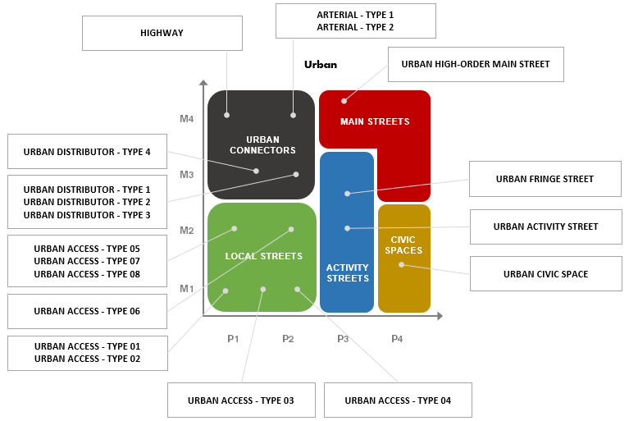

Figure 4-14: Movement and Place mapped matrix of acceptable concept typologies – Urban

As MX and PX have been determined for each street, the associated concept typology drawing is identified.
Each concept typology is considered an ‘acceptable solution', where the typology road form represents five (5) different elements;
a) Movement and Place classification – MX/PX
b) Modal attributes –modes the typology caters for (or not)
c) Plan view – technical plan view details
d) Typical cross section – technical cross section details
e) Technical notes – technical design details associated with detailed design

Commentary: The initial MX/PX determination is subjective but guides the designer on possible suitable typologies through the design process. The designer, now informed with an understanding of design movement and place aspects relative to the street as well as modal priorities and any design environment considerations, can view the concept typology for its suitability for the given project.
The concept typology associated with each streets MX/PX classification is shown below.
Street | PX | Function | MX | Modal Priority | PX/MX & Possible Typologies | …
Street A | P1 | Access | M1 | People walking, people cycling, private vehicles | Local Street |  Urban Access  Type 01, 02, 03
Street B | P1 | Access | M1 | People walking, private vehicles
Street C | P2 | Access /  Collector | M2 | People walking, private vehicles, vehicle parking, people cycling, public transport | Local Street |  Urban Access  Type 06
Street D | P3 | Access /  Collector | M2 | People walking, private vehicles, vehicle parking, people cycling, public transport | Activity Street |  Urban Activity Street
Street E | P1 | Access | M1 | People walking, private vehicles, people cycling, public transport | Local Street |  Urban Access  Type 01
Street F | P1 | Access | M1 | People walking, private vehicles
Street G | P1 | Collector | M2 | Private vehicles, public transport, people walking, people cycling | Local Street |  Urban Access  Type 05, 07, 08

7. Concept Typology Evaluation Decision Tree
Each street now has recognised aspects for movement, place, modal priority, and design environment.
Each street now has an associated MX/PX classification and an associated concept typology.
The suitability of the concept typology for the given project is then evaluated. The following flow-chart illustrates an iterative design process the designer may undertake.
If the concept typology is aligning to the project design aspects identified, then the concept typology would be suitable to adopt.
If the concept typology is not suitable, then an alternative typology could be reviewed and assessed for suitability, or, the designer may opt to amend an existing typology or design an alternative typology for use.

8. Alternate Concept Typology Design Framework
Where any of the suite of concept typologies are not suitable for the project, the Designer may propose an alternative street typology design.
Alternative typology designs shall be certified by an RPEQ and address the minimum requirements defined in section 4.7 of the Geometric Road Design PSP, as follows:
a) Defined movement value
b) Defined place value
c) Defined modal priorities

By applying the Build-a-Street concept (IPWEA SDM), the Designer can develop a unique cross-section for the project that addresses the specific project scenario. The cross-section can then be used to guide the overall design of the project. This approach will allow for innovation in the design process to achieve an optimal transport corridor width and design that will meet the project objectives.
The design of the cross-section can be done in two parts; the Transport corridor which includes the On-street corridor (kerb to kerb) and the Verge, see Figure 4-12. Guidance on the performance outcomes for the design of the Transport corridor is provided in Table 4-8.

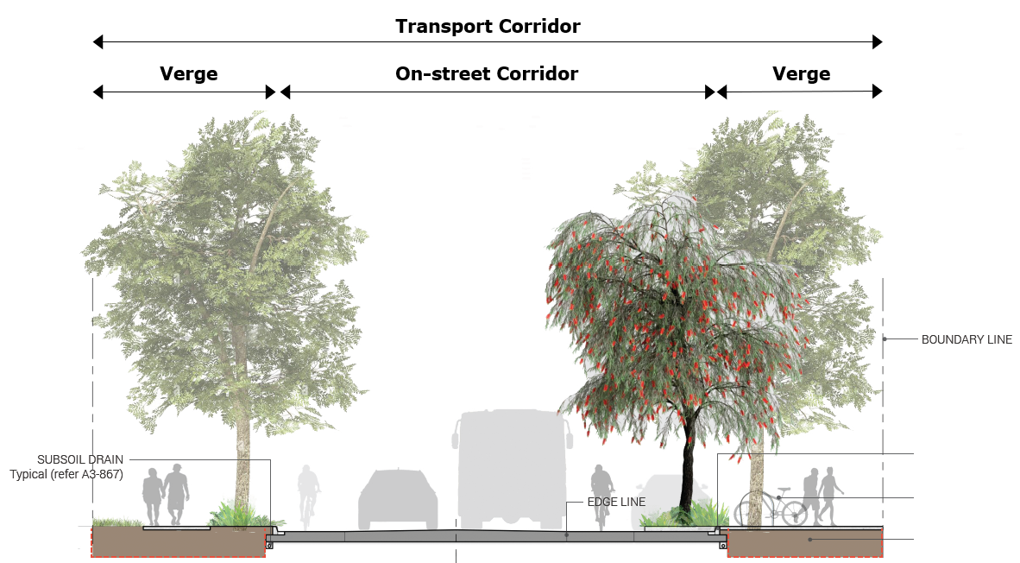
Figure 4-15: ‘Build a street’ typology design elements

Table 4-8: Transport Corridor Design Elements
Element | Description | Performance Outcomes
Transport Corridor | The total transport corridor width (‘road reserve’) is the sum of the on-street corridor width and verge widths. | Road designers should maintain a constant transport corridor width for continuous road links and avoid having distinct variations to accommodate specific elements within the corridor. Where there is a need to accommodate varying the widths, these should be achieved through appropriate transitions.
On-Street Corridor | The on-street corridor is principally about the movement function and caters for modal throughputs. | The on-street corridor design should consider various road design elements associated with identified modal priorities and movement and place characteristics. Design elements such as lane widths, number of carriageways, shoulder widths (if any), or medians (if any) are to be considered, as well as any modal specific requirements such as on-street cycles lanes, physical separation or on-street parking. The arrangement of these elements forms the ‘on-street corridor’.
Verge | The verge is the public off-street corridor between the on-street corridor and adjacent road-property boundary. | The verge typically caters for pedestrian and cyclist movement on shared pathways and supports place functions that relate to the use of the verge relating to surrounding land use or within the verge itself.  The verge may also cater for specific place activities which support the adjacent land use such as driveway crossings or full-width hard paved surfacing for pedestrians’ typical adjacent active frontages.  The verge also provides a critical role for location of PUP, such as water reticulation, communications, power, gas as well as above ground infrastructure such as street lighting and overhead powerlines. These services are assigned designated service corridors within the road reserve.  The verge design shall also consider identified modal priorities, and movement and place characteristics. The verge design shall consider modal priority such as cycling and walking and how these modes are to be catered for within the verge while integrating with other functions.  For the purposes of the verge cross section design and modal priority, this generally relates to walking and cycling modes only. On-street parking, bus set-downs areas (and shelters), good and servicing loading, private vehicles and freight movement requirements are considered as part of the on-street corridor design process above. Notwithstanding, there may be other design elements not listed which may influence the verge width and are to be considered.

9. Concept Typology Evaluation & Cross Section Design
Each street typical cross section is now defined. The movement and place design process suggests that the Designer review each streets Movement and Place classification previously determined to determine if the cross section is suitable for;
- Function & Movement (MX)
- Modal priority
- Place (PX) &
- Design Environment

Each street is review and assessed in the below table.
Street | PX | Function | MX | Modal Priority | PX/MX & Possible Typologies | Typology Evaluation
Street A | P1 | Access | M1 | People walking, people cycling, private vehicles | Local Street |  Urban Access  Type 01, 02, 03 | P1/M1 = Type 01 & 02 – not suitable.  Reviewing other ‘Local Street’ typologies:  Type 03 (P1-2/M1) - more suitable, however only a single 1.5m path provided. Modal priorities are high demand for people walking and cycling, so suggest min. 2.5m shared path + a 1.5m path. 6.0m wide carriageway OK for an access function street  Type 04 (P2/M1) – may also be more suitable.  Outcome: Adopt an alternative typology with a 5.0m wide verge with a 2.5m path on northern verge & 5.0m wide southern verge with a 1.5m wide path & 6.0m wide carriageway. Total formation width = 16m.
Street B | P1 | Access | M1 | People walking, private vehicles |  | P1/M1 = Type 01 & 02 – not suitable.  Reviewing other ‘Local Street’ typologies:  Type 03 (P1-2/M1) – OK but has 5.5m carriageway width and pathway on one verge for walking.  Type 04 (P2/M1) – Paths on both sides and 6.0m carriageway meets project requirements.  Outcome: Adopt Type 04 typology. Total formation width = 15m.
Street C | P2 | Access /  Collector | M2 | People walking, private vehicles, vehicle parking, people cycling, public transport | Local Street |  Urban Access  Type 06 | P2/M2 = Type 06 – not suitable, as no on-street parking modal provision.  Reviewing other ‘Local Street’ typologies:  Type 08 (undivided) (P1/M2) – has provision for parking to be adapted, paths both sides for active transport incl. 2.5m wide shared path.  Outcome: Adopt Type 08 typology but amend shoulder to allow for parallel on-street parking and have 2.5m wide shared paths on both verges. Total formation width = 24m.
Street D | P3 | Access /  Collector | M2 | People walking, private vehicles, vehicle parking, people cycling, public transport | Activity Street |  Urban Activity Street | P3/M2 = Urban Fringe Street, suitable paths for people walking incl. 5.0m wide pathway suitable for adjacent local centre/high density residential zoning, capacity for thru traffic, capacity for on-street parking and on-street cycling and pathway. WSUD provision not required in design.  Outcome: Adopt Urban Fringe Street typology but amend 2.0m pathway to 2.5m pathway & remove provision for WSUD. Total formation width = 23.5m.
Street E | P1 | Access | M1 | People walking, private vehicles, people cycling, public transport | Local Street |  Urban Access  Type 01 | P1/M1 = Type 01 & 02 – not suitable.  Reviewing other ‘Local Street’ typologies:  Type 03 (P1-2/M1) – OK but has 5.5m carriageway width and pathway on one verge for walking.  Type 04 (P2/M1) – Paths on both sides and 6.0m carriageway, however not suited to buses as there may be need for PT.  Type 06 (P2/M2) – 5.0m verges and 7.5m carriageway, caters for active transport, private vehicles, public transport provisions.  Outcome: Adopt Type 06 typology but increased southern verge path from 1.5m to 2.5m wide. Total formation width = 17.5m.
Street F | P1 | Access | M1 | People walking, private vehicles |  | P1/M1 = Type 01 & 02 – not suitable.  Reviewing other ‘Local Street’ typologies:  Type 03 (P1-2/M1) – OK with 5.5m carriageway width and pathway on one verge for walking. Self-contained local street with minimal external movements through.  Outcome: Adopt Type 03 typology. Total formation width = 13.5m.
Street G | P1 | Collector | M2 | Private vehicles, public transport, people walking, people cycling | Local Street |  Urban Access  Type 05, 07, 08 | P1/M2 = Type 07 & 08 – A median separation is not required, as such Type 07 is not suitable. Type 08 has provision for private vehicles, public transport, people walking and people cycling. The subdivision is intended to have lot access internally – i.e. no lot access via the collector, as such active transport may utilise the eastern verge path and on-street parking in the shoulder is not required or desired.  Outcome: Adopt Type 08 typology with a reduced eastern shoulder 1.5m wide to mitigate on-street parking but have provision for on-street cycling and a 2.5m wide path on eastern verge for active transport. Total formation width = 23m.

Typical cross-sections for each street and how each design modal priority is being catered for is shown below;
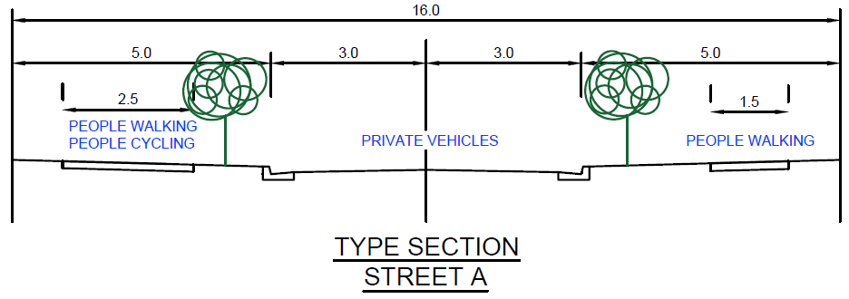
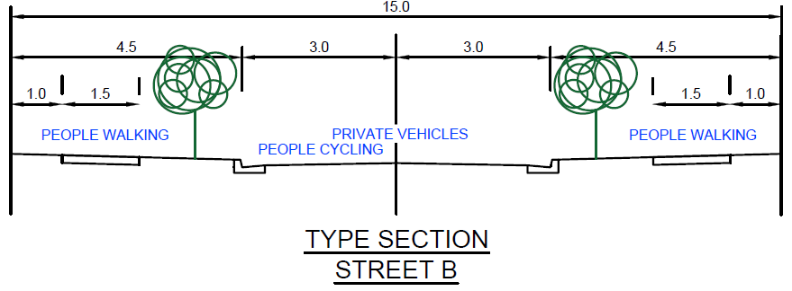
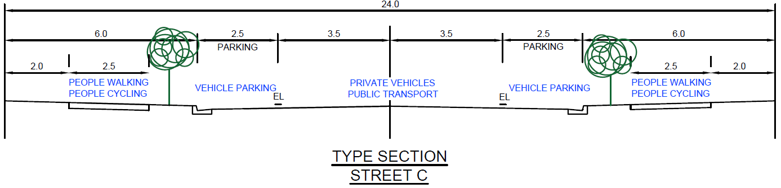
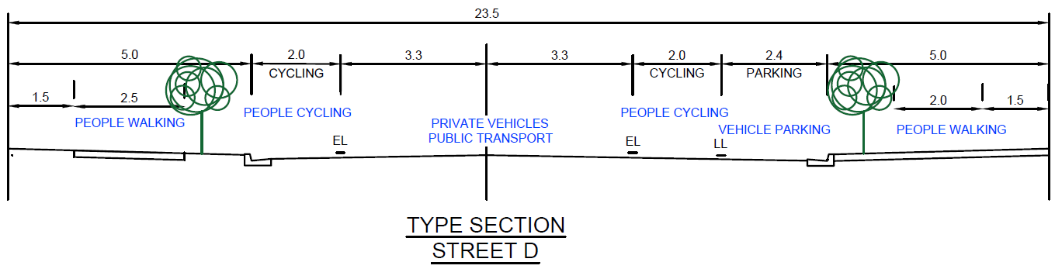
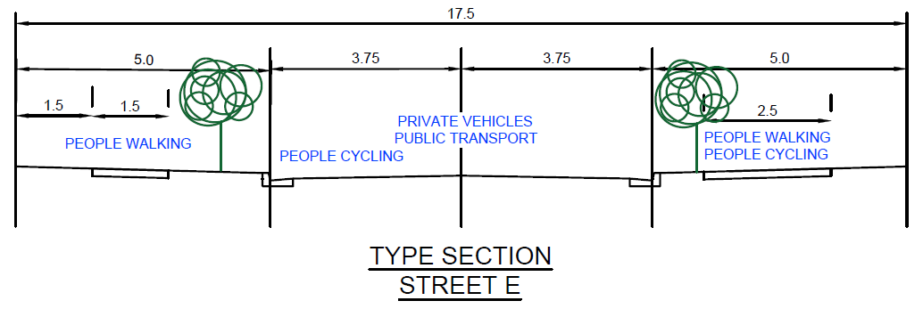
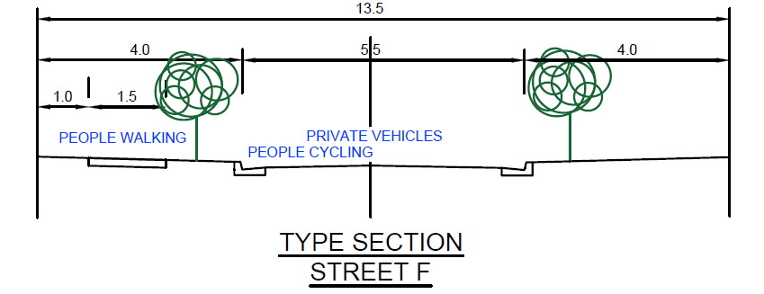
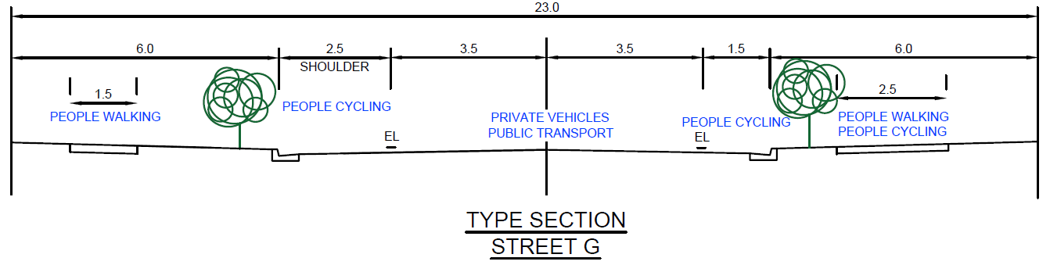

10. Summary
Each street now has a typical cross section design which reflects the movement, place, mode priority and design environment requirements of each.
This is summarised in the Movement and Place Framework Design Summary table below.

Street | PX | Function | MX | Modal Priority | PX/MX Possible Typologies | Adopted Typology | Adopted Reserve Width
Street A | P1 | Access | M1 | People walking, people cycling, private vehicles | Local Street |  Urban Access  Type 01, 02, 03 | Adopt an alternative urban access typology proposed as a 5.0m wide verge with a 2.5m path on northern verge & 5.0m wide southern verge with a 1.5m wide path. | 16.0m
Street B | P1 | Access | M1 | People walking, private vehicles |  | Adopt Urban Access Type 04 typology | 15.0m
Street C | P2 | Access /  Collector | M2 | People walking, private vehicles, vehicle parking, people cycling, public transport | Local Street |  Urban Access  Type 06 | Adopt Urban Access Type 08 typology with shoulder space reallocated to allow for parallel on-street parking and adopt a 2.5m wide shared path on both verges. | 24.0m
Street D | P3 | Access /  Collector | M2 | People walking, private vehicles, vehicle parking, people cycling, public transport | Activity Street |  Urban Activity Street | Adopt Urban Fringe Street typology with a 2.5m pathway in lieu of 2.5m wide pathway & remove provision for WSUD. | 23.5m
Street E | P1 | Access | M1 | People walking, private vehicles, people cycling, public transport | Local Street |  Urban Access  Type 01 | Adopt Urban Access Type 06 typology with increased southern verge path from 1.5m to 2.5m wide. | 17.5m
Street F | P1 | Access | M1 | People walking, private vehicles |  | Adopt Urban Access Type 03 typology. | 13.5m
Street G | P1 | Collector | M2 | Private vehicles, public transport, people walking, people cycling | Local Street |  Urban Access  Type 05, 07, 08 | Adopt Urban Access Type 08 typology with a reduced eastern shoulder 1.5m wide and a 2.5m wide path in lieu of 1.5m on eastern verge. | 23.0m

Movement & Place Framework Design Summary Table

11. Documentation
For any MCU, ROL or OW planning application, or any design project, the following documentation is required to demonstrate that appropriate Movement and Place design considerations have been undertaken:
- The Movement and Place Framework Design Summary (MPFDS) table shall be completed and submitted as part of any relevant submission which involves the planning or design of a typology or road cross section. Refer Geometric Road Design PSP Appendix B – Movement and Place Design Framework summary table.

- The submission shall also include legible typical cross sections of each street showing which modal priority is serviced within the cross section (see Figure 4-16). Alternative documentation may be presented, so long as the relevant Movement and Place design considerations have been appropriately explored and demonstrated.

- The submission of the MPFDS, or similar documentation, should reflect the nature and complexity of the accompanying planning application or proposed design.

Figure 4-16: Example typical cross section/typology with transport mode details
The main role of the MPFDS, and supporting documentation, is to:
- Ensure that the design responds to the Place value and the Council’s Planning Scheme Policies have been addressed
- Demonstrate how the objectives of best practice design for Movement and Place have been applied and existing and future user needs have been incorporated
- Show how access needs have been designed and are responsive to adjacent land uses

Provide for a legible typical cross section of the street and demonstrate how transport modes are catered for.
A suitably experienced practitioner or professional engineer (RPEQ) may endorse the applicable MPFDS submission, and any supporting documentation. The MPFDS is found in Appendix B – Movement and Place Design Framework Summary.

