Planning Scheme Policy - Geometric Road Design
Application of Movement and Place Framework
Practice Note #2 – Brownfield Development Example
_________________________________________________________________________________

About Movement and Place
The Movement and Place approach to planning and design recognises that roads facilitate the movement of people and goods by various modes of transport, as well as provide places for people and activity.
This approach builds on the functional road hierarchy by incorporating modal priority with modal mobility and acknowledges that streets and roads provide public spaces that often do more than facilitate movement and access. Streets also provide the space and places for recreation, social and cultural exchange and often economic activity. This approach aims to facilitate greater enjoyment of the surrounding environment and amenity, as well as opportunities for economic activity and vitality.
The Movement and Place approach focuses on the future aspirations for a street and provides a framework to establish a shared vision that can balance both the transport and land use activity objectives to guide the planning and design process to get improved outcomes.

Movement and Place Design Framework
The MRC Movement and Place Design Framework has four (4) key inputs which all contribute to determining the design outcome and final design form of the street. The four (4) key inputs which will need to be considered to inform the design process include:
1) Place value
2) Movement value
3) Modal priority assessment
4) Design environment
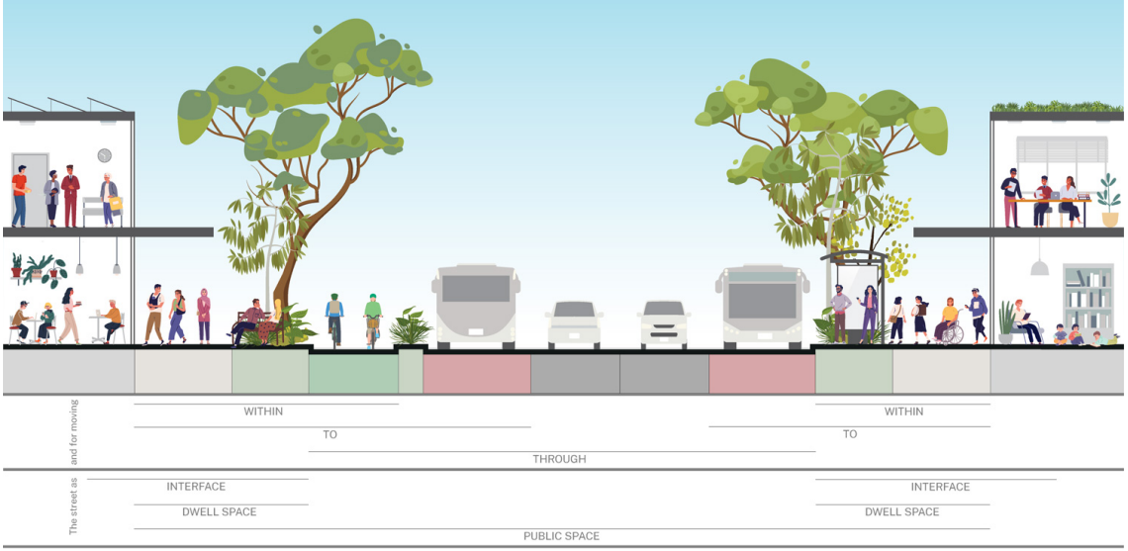
Source: Design of roads and streets (NSW)

Case Study #2: Bay Road - Brownfield Development

1. PROJECT DETAILS, LAND USE & STREET LAYOUT
Bay Road is a hypothetical existing urban distributor function road in the Mackay region.
The road has a reduced level of service and is experiencing extensive pavement failures as such requires rehabilitation. Since the road was originally built, the adjacent land use which fronts the road has undergone significant growth and development, including a new school and a shopping centre – which has changed the land use.
The failing pavement and recognition of changed land use presents an opportunity to renew the pavement and integrate land use into the design by applying the Movement and Place framework.
The entire road reserve is being considered for reconstruction.

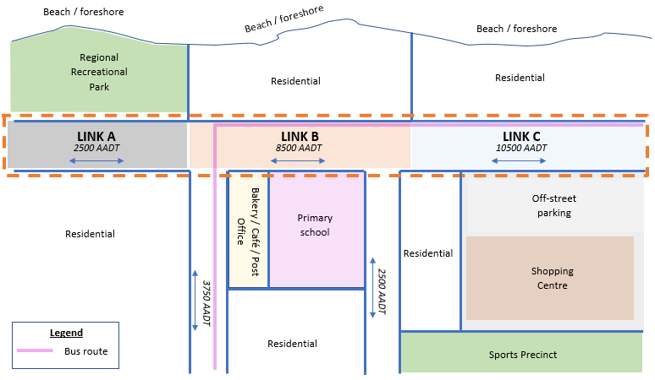
Figure 1 – Bay Road Layout

2. Site Background Info & Design Considerations
The design of the road reserve (property boundary to property boundary) would need to consider all transport mode demands including private vehicles, cycling & micromobility, walking, parking cars, freight, goods and services. And consider potential activity of associated land uses and how the street design should engage with the land use activity.
The road can be looked at in three (3) links each of which have different land uses which may correspond to alternate road forms.

Parameter | Info
AADT | As shown on layout plan
Design Horizon | +10 years
Road Hierarchy | Traffic Distributor
Road Reserve Width | 26.0m
Pedestrian movements | Busy around and to/from activity centres (park, shops, sports)
Cycling movements | Busy along Bay Road
Public transport | Bus route mapped (see layout plan)
Private vehicles | Largely contributes to AADT
Parking of bicycles & e-scooters | Possibly required, associated with demand
Goods and services | Required to service associated land uses
Freight | Minimal to nil %HV

The next steps will assess and identify movement and place design attributes for each link as summarised in the below table, discussed further in this guidance document.

Street | PX | Function | MX | Modal Priority | PX/MX Possible Typologies | Adopted Typology | Adopted Reserve Width (m)
Link A
Link B
Link C

3. Determining the Place Value
The Place value is determined through a subjective assessment of the subdivision area and the anticipated level of activity within the street, how any use of the street interacts or is engaged with the adjoining land uses, and the scale of which the place is anticipated to attract.
This will primarily be based on the relative catchment of users and/or activity and its importance at either a local, neighbourhood, locality/suburb or at a regional scale.
All seven (7) streets are assessed below. Refer Figure 4-8 for typical urban place value characteristics.
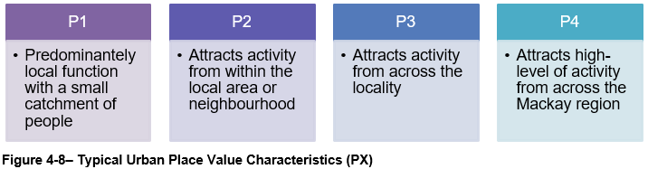
Street | PX |  | …
Link A | P3 | Regional park attracts activity across the region – as such nominate a P3 score, a greater place score than Links B and C.
Link B | P2 | Residential use and primary and commercial use on frontages, P2 score assigned for local area/neighbourhood activity.
Link C | P1 | Residential properties each side and well as a shopping centre complex with off-street parking. A P1 score is allocated as the off-street parking doesn’t necessarily engage with the frontage and activity of the shopping centre is largely generated within the lot, not with the street.
Tips:
- A street with retail, restaurants, cafes along its frontage may attract people from a wider catchment and thus have a higher strategic significance for Place. A residential street with no other uses will attract people from a much smaller catchment and will have a lower strategic significance for Place. The Designer should also observe local themes and existing place aesthetics that already exist in the area of the project and decide whether these existing themes should also be integrated into the design.
- In greenfield and other situations where no design palette exists, the purpose of a place making approach is to build on the existing character and values of an area rather than contrive it. Accordingly, there will be instances where conditions of development approval will specifically require that design of infrastructure be consistent with Council’s adopted place making approach for the particular locality.
- If the road or street corridor is likely to have varying characteristics along its length, split into sections with like characteristics.

4. Determining the Movement Value
The Movement value is one of the key inputs into the determination of the MRC Movement and Place class. Movement value is scored between M1, though to M4 and is determined through a subjective assessment of the function of the link.
This assessment will need to consider all transport modes and their modal priority. This is based around its strategic importance in the network such as hierarchical function (Figure 3-2), the size or scale of the service catchment and the level of demand.
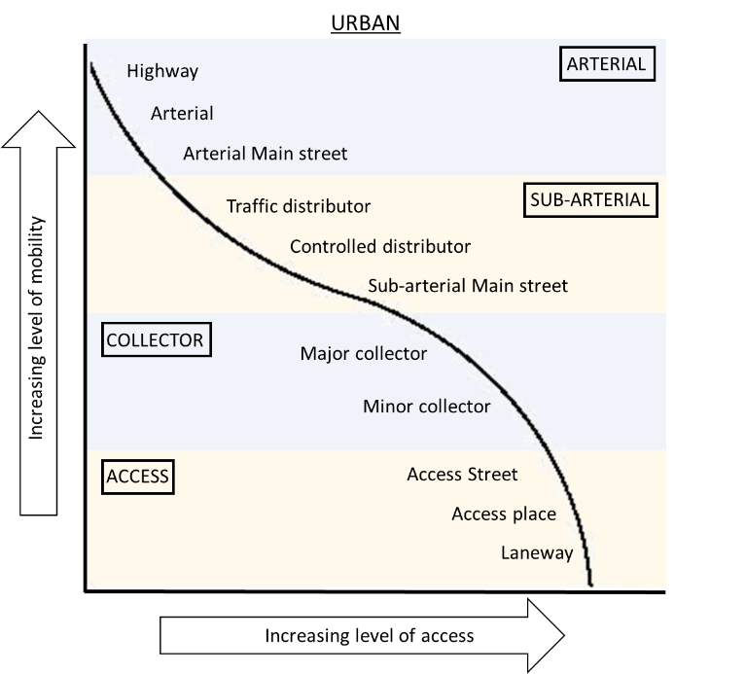
Figure 3-2 – MRC Road Hierarchy Classification - Urban

All three (3) links of Bay Road are initially assessed below. Refer Figure 4-10 for the typical movement value characteristics.
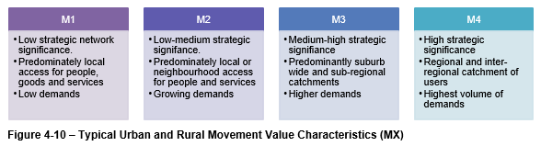

Street | PX | Function |  | MX |  | …
Link A | P3 | Access / Collector | Local residential access mainly, however, provide regional access to District Park | M2 | Low-medium strategic significance. AADTs suggest lower traffic volumes compared to Links B and C.
Link B | P2 | Collector / Distributor | Predominately neighbourhood access to primary school and shops | M2 | Low-medium strategic significance. AADTs suggest greater volume of traffic than Link A, but less than Link C
Link C | P1 | Distributor | Predominately suburb wide catchment with shopping centre | M3 | Medium-high strategic significance. AADTs are highest of the three links. The form of Link C is closely related to Link B
Tips:
- MRC’s functional road hierarchy will be a useful starting point as the Road hierarchy classification will provide an indication of the importance of the link from a mobility and access perspective. Where Arterial roads have a high strategic significance, and Access streets have lower strategic significance. However, it is important to note that the alignment to the MRC functional road hierarchy will not strictly define the movement value as all modes and their priorities/ demands also need to be considered.

- Movement significance should be assessed for all modes such as people travelling on foot, by bike, by micro-transport (e.g., e-scooter), by bus, and movement of freight and services. Avoid basing movement values solely on traffic volumes – consider the criticality of the route within the network.
- Roads and streets perform an important access function, including access to residential properties, local services, public transport services, and distribution of freight. Regardless of the mode of travel, the priority for the Movement function is about moving people, goods and/or services safely, efficiently, and reliably.
- A road with a high pedestrian, cyclist or public transport use will have a higher movement significance than a road with local or less frequent movement.

- Movement assessment must consider all modes and their respective strategic modal networks. If a road or street is a high-level strategic route for any mode, that should be reflected in the movement significance.

5. Determining Modal Priorities
Modal priority is about understanding who uses the road link, for what purpose and by which transport mode and then having some relativity between modes. This enables planners, designers and decision makers to consider and develop options through the design process that will respond appropriately to each mode and better understand how certain design outcomes will benefit or impact specific modes.
In simple terms, when constrained for space – which transport mode is prioritised over another when allocating limited space for infrastructure or services?
A mode with a higher level of priority is considered more important than another with lower priority and therefore is afforded greater weight in the design process.
The modes defined in the MRC Movement and Place Design Framework that are required to be considered in the assessment include:
- People walking
- People cycling and using micro-mobility
- People using public transport
- Goods by road freight
- People in private vehicles
- Goods loading and servicing
- People parking private vehicles
- People parking bicycles and other micromobility.

The three (3) links are assessed and the MPFT is used to help illustrate and understand the adopted modal priorities.
Commentary: The MPFT modal priority tool has a numerical scale. The scale is arbitrary and used to aid the designer in determining modal priorities. Assessments are subjective, with the assessment process providing the designer the opportunity to review and understand modal priorities and form a basis to inform design decisions throughout the project.
LINK A
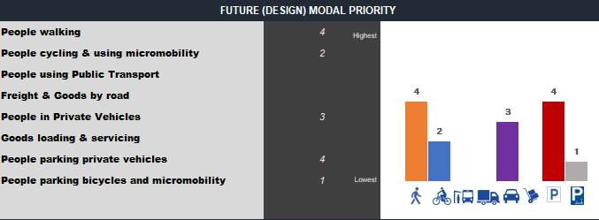
Walking and parking of private vehicles is identified as the highest priority in Link A, followed by people in private vehicles. People cycling and parking of micromobility devices is the lowest priority. Freight, goods and services and public transport do not feature and are not considered in this link.
Commentary: These assigned priorities indicate that people walking and parking of private vehicles is a priority for this link.
LINK B
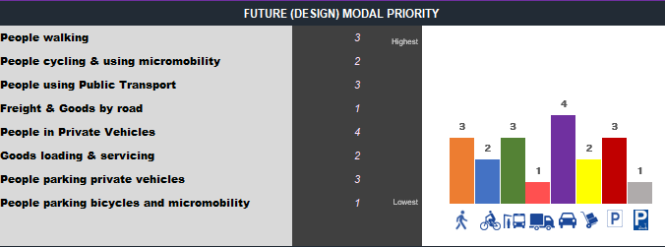
Link B is busy across all modes. Private vehicles is identified as the highest priority, followed by parking of private vehicles, public transport and people walking. Cycling and goods loading and servicing is then considered as the next priority, followed by freight and goods by road and micromobility parking.
Commentary: These assigned priorities indicate that there may be a need for on-street loading for goods and services, and bus set down facilities along this link – if not provided for elsewhere in the vicinity. Similarly there is priority identified for parking of private vehicles where available road space would need to be balanced with any loading or bus set down facilities. Above all else, people walking is the highest priority which would indicate suitable facilities for walking such as wide paths and potentially sufficient crossing facilities provided for. The priority for people walking could even warrant a priority raised midblock crossing on Link B to facilitate the movement of people at this link – an element to be considered further in detailed design.
LINK C
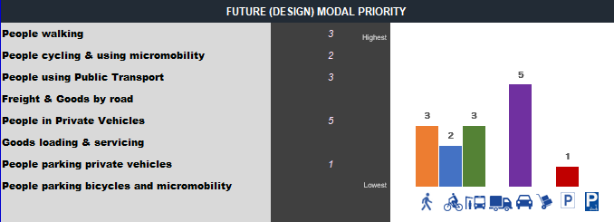
People in private vehicles is identified as the highest priority in Link C, followed by people walking and public transport, then people cycling and parking of private vehicles as the lowest priority.
Commentary: Private vehicles is the highest priority and suggests vehicle movements in this link service movement to and from the area. The link caters for a bus route and may require a bus set down area, however a bus set down area would be considered along with the adjacent links in the area. People walking is still recognised as having reasonable level of activity and it is expected path infrastructure to be appropriately design for. Parking of private vehicles is considered as low priority which suggest that on-street parking is not required.

Street | PX | Function | MX | Modal Priority | …
Link A | P3 | Access | M2 | People walking, parking private vehicles, private vehicles, people cycling
Link B | P2 | Collector / Distributor | M2 | Private vehicles, parking private vehicles, Public Transport, People walking, People cycling
Link C | P1 | Distributor | M3 | People walking, private vehicles, vehicle parking, people cycling, public transport
Tips:
- Movement and Place value information will be useful for determining modal priority

- Modal priority can be thought of as ‘deciding the most import mode(s) to allocate the limited space available in a transport corridor’.
- The observed modal priority in the Existing state for a road or street is the current observed prioritisation of modes when looking at the existing form of the available infrastructure.

- The optimal modal priority assessment is to understand what modal priority should be, compared to what it currently is.

- The future modal priority horizon outlines any anticipated change in relative priorities based on future strategic networks and land uses. This informs the design process.

- Assigning modal priorities is designed to highlight the mode in the first instance and not delve into solving design issues, in this step.

6. Design Environment
The final input in the process is to understand the design environment and how it can influence the design process and project outcomes. This is achieved through identification and appreciation of the constraints within and adjacent to the road and by better linking the project objectives to other values that do not sit directly with movement or place.
Refer Table 4-5 for an overview of some the potential design environment measures that need to be considered.
Additionally, one of the key factors in the design will be the presence of, or the provision for public utility plant (PUP) or recognised assets. These different types of infrastructure and services require provision for space, clearances, and offsets within the road corridor and are a key constraint to the final road design. The typical PUP services to be considered within the road corridor includes:
a) Gravity sewer reticulation
b) Sewer rising mains
c) Electrical services (including pits, pillars, and poles, HV services)
d) Telecommunication services (including pits and pillars)
e) Watermains
f) Gas reticulation
g) Street lighting
h) Street trees

Given ‘Hypothetical Bay’ is a greenfield development, and it is assumed that there is little existing infrastructure, most services, environment or heritage measures are not applied. However, we can assume that there is existing vegetation of significance that should be retained, as such the masterplan layout has established parkland to preserve the existing vegetation.

Table 4-5: Design environment measures
 | Measure | Information | Source
Services | Service corridors | Identify key service corridors to understand priority service corridors | Service providers  MRC MiMaps
 | Service locations | Identify design constraints and inform options development | Dial Before You Dig  MRC MiMaps  Feature survey DTMs
 | Access | Driveways and recognised lot access locations
Environmental | Significant trees | There may be trees that are established within an area that provides value to the movement or place values. This could be through their habitat value, shading, rarity, historical associations or contribution to the landscape. | Biodiversity – Environmentally significant vegetation overlay  MRC Significant Tree Register  Feature survey DTM  Site photographs  State Vegetation Mapping
 | Landscapes | Some places will provide amenity, social, economic or environmental value as a result of their geographic features and amenity values which need to be incorporated or enhanced as part of the design. | MRPS  Surveys
Heritage | Heritage register | Some places may have significant heritage value that need to be protected and/or enhanced through planning and design. | MRC Local Heritage Places  MRPS  Queensland Heritage Register
 | Cultural heritage | Some places have significant cultural heritage significance to Traditional Owners and need to be protected through planning and design. | Cultural heritage database and register  Recognised Traditional Owner groups

7. Movement and Place Classification
The assignment of a Movement and Place classification provides guidance on the road form, either directly associated with the MX/PX matrix, or similar, which aligns to the movement and place values identified for the road link.
Concept typologies are notionally arranged as per Figure 4-14.

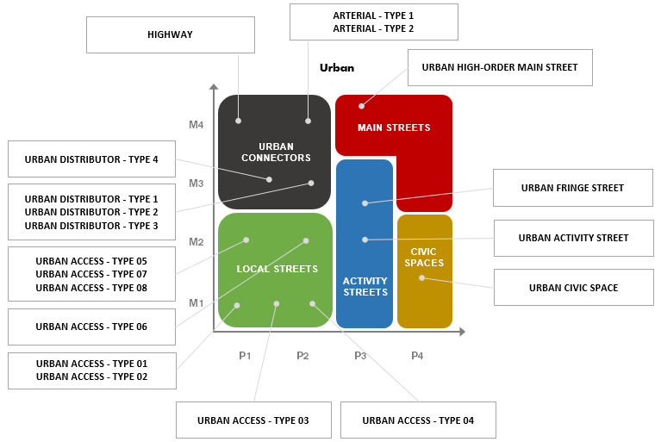

Figure 4-14: Movement and Place mapped matrix of acceptable concept typologies – Urban

As MX and PX have been determined for each street, the associated concept typology drawing is identified.
Each concept typology is considered an ‘acceptable solution', where the typology road form represents five (5) different elements;
a) Movement and Place classification – MX/PX
b) Modal attributes –modes the typology caters for (or not)
c) Plan view – technical plan view details
d) Typical cross section – technical cross section details
e) Technical notes – technical design details associated with detailed design

Commentary: The initial MX/PX determination is subjective but guides the designer on possible suitable typologies through the design process. The designer, now informed with an understanding of design movement and place aspects relative to the street as well as modal priorities and any design environment considerations, can view the concept typology for its suitability for the given project.

The concept typology associated with each streets MX/PX classification is shown below.
Street | PX | Function | MX | Modal Priority | PX/MX & Possible Typologies | …
Link A | P3 | Access | M2 | People walking, parking private vehicles, private vehicles, people cycling | Activity Street |  Urban Fringe Street
Link B | P2 | Collector / Distributor | M2 | Private vehicles, parking private vehicles, Public Transport, People walking, People cycling | Local Street |  Urban Access  Type 06
Link C | P1 | Distributor | M3 | People walking, private vehicles, vehicle parking, people cycling, public transport | Urban Connector |  Distributor  Type 04

8. Concept Typology Evaluation Decision Tree
Each street now has recognised aspects for movement, place, modal priority, and design environment.
Each street now has an associated MX/PX classification and an associated concept typology.
The suitability of the concept typology for the given project is then evaluated. The following flow-chart illustrates an iterative design process the designer may undertake.
If the concept typology is aligning to the project design aspects identified, then the concept typology would be suitable to adopt.
If the concept typology is not suitable, then an alternative typology could be reviewed and assessed for suitability, or, the designer may opt to amend an existing typology or design an alternative typology for use.

9. Alternate Concept Typology Design Framework
Where any of the suite of concept typologies are not suitable for the project, the Designer may propose an alternative street typology design.
Alternative typology designs shall be certified by an RPEQ and address the minimum requirements defined in section 4.7 of the Geometric Road Design PSP, as follows:
a) Defined movement value
b) Defined place value
c) Defined modal priorities

By applying the Build-a-Street concept (IPWEA SDM), the Designer can develop a unique cross-section for the project that addresses the specific project scenario. The cross-section can then be used to guide the overall design of the project. This approach will allow for innovation in the design process to achieve an optimal transport corridor width and design that will meet the project objectives.
The design of the cross-section can be done in two parts; the Transport corridor which includes the On-street corridor (kerb to kerb) and the Verge, see Figure 4-15. Guidance on the performance outcomes for the design of the Transport corridor is provided in Table 4-8.

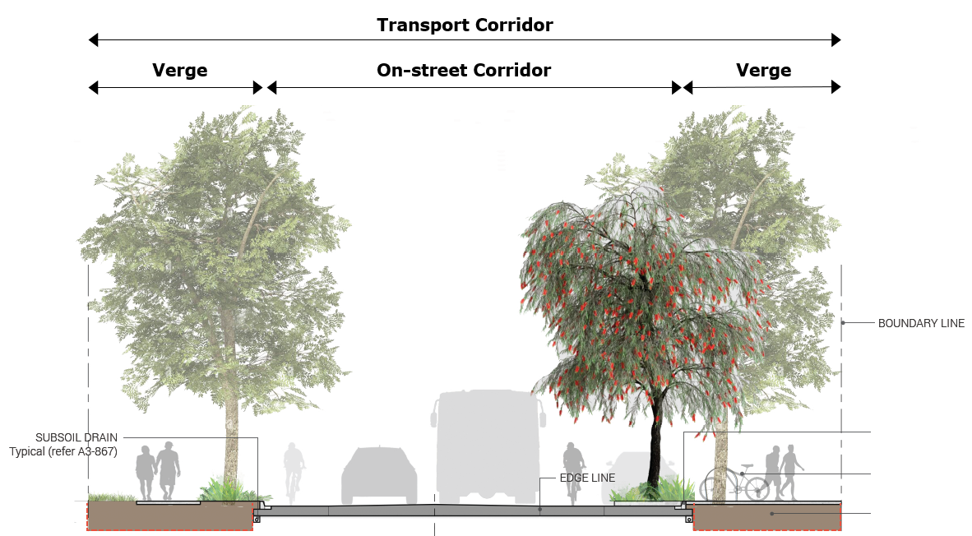
Figure 4-15: ‘Build a street’ typology design elements

Table 4-8: Transport Corridor Design Elements
Element | Description | Performance Outcomes
Transport Corridor | The total transport corridor width (‘road reserve’) is the sum of the on-street corridor width and verge widths. | Road designers should maintain a constant transport corridor width for continuous road links and avoid having distinct variations to accommodate specific elements within the corridor. Where there is a need to accommodate varying the widths, these should be achieved through appropriate transitions.
On-Street Corridor | The on-street corridor is principally about the movement function and caters for modal throughputs. | The on-street corridor design should consider various road design elements associated with identified modal priorities and movement and place characteristics. Design elements such as lane widths, number of carriageways, shoulder widths (if any), or medians (if any) are to be considered, as well as any modal specific requirements such as on-street cycles lanes, physical separation or on-street parking. The arrangement of these elements forms the ‘on-street corridor’.
Verge | The verge is the public off-street corridor between the on-street corridor and adjacent road-property boundary. | The verge typically caters for pedestrian and cyclist movement on shared pathways and supports place functions that relate to the use of the verge relating to surrounding land use or within the verge itself.  The verge may also cater for specific place activities which support the adjacent land use such as driveway crossings or full-width hard paved surfacing for pedestrians’ typical adjacent active frontages.  The verge also provides a critical role for location of PUP, such as water reticulation, communications, power, gas as well as above ground infrastructure such as street lighting and overhead powerlines. These services are assigned designated service corridors within the road reserve.  The verge design shall also consider identified modal priorities, and movement and place characteristics. The verge design shall consider modal priority such as cycling and walking and how these modes are to be catered for within the verge while integrating with other functions.  For the purposes of the verge cross section design and modal priority, this generally relates to walking and cycling modes only. On-street parking, bus set-downs areas (and shelters), good and servicing loading, private vehicles and freight movement requirements are considered as part of the on-street corridor design process above. Notwithstanding, there may be other design elements not listed which may influence the verge width and are to be considered.

10. Concept Typology Evaluation & Cross Section Design
Each street typical cross section is now defined. The movement and place design process suggests that the Designer review each streets Movement and Place classification previously determined to determine if the cross section is suitable for:
- Function & Movement (MX)
- Modal priority
- Place (PX) &
- Design Environment

Each street is reviewed and assessed in the below table.
Street | PX | Function | MX | Modal Priority | PX/MX & Possible Typologies | Typology Evaluation
Link A | P3 | Access | M2 | People walking, parking private vehicles, private vehicles, people cycling | Activity Street |  Urban Fringe Street | P3/M2 = Urban Fringe – potentially suitable.  Reviewing other typologies for suitability:  Activity Street – urban activity (parking priority) (P3/M1) - more suitable with provision for parking and active transport modes.  Outcome: Adopt Activity Street – urban activity (parking priority) typology.  Total formation width = 26m.
Link B | P2 | Collector / Distributor | M2 | Private vehicles, parking private vehicles, Public Transport, People walking, People cycling | Local Street |  Urban Access  Type 06 | P2/M2 = Type 06 – not suitable, traffic volumes warrant greater through lane and shoulder widths plus provisions for linemarking and delineation.  Reviewing other ‘Local Street’ typologies:  Type 07 (P1/M2) – median divided – typology caters for private vehicles, on-street parking, people cycling and people walking. Median provides channelisation treatment.  Outcome: Adopt Urban Access Type 07 typology.  Total formation width = 26m.
Link C | P1 | Distributor | M3 | People walking, private vehicles, people cycling, public transport | Urban Connector |  Distributor  Type 04 | P1/M3 = Urban Connector Type 04 – provides for private vehicles, people cycling, people walking, and public transport. Undivided. Potentially suitable.  Reviewing other ‘Urban Connector’ typologies:  Type 02 (undivided) (P2/M3) – similar to Type 04 typology, with the addition of allocating the 2.5m wide shoulder to on-street parking. On-street parking is not a priority, as such Type 02 is not suitable.  Type 01 (divided) (P2/M3) – similar to Type 04 typology, however has a 3.0m wide median, however has a total reserve width of 30.0m which exceeds the existing road reserve with of 26m.  Reviewing other ‘Local Access’ typologies:  Type 07 (divided) – caters for the design modal priorities within 26m road reserve.  Outcome: Adopt Urban Access Type 07 (divided) typology.  Total formation width = 26m.

Typical cross-sections for each street and how each design modal priority is being catered for is shown below;
Link A
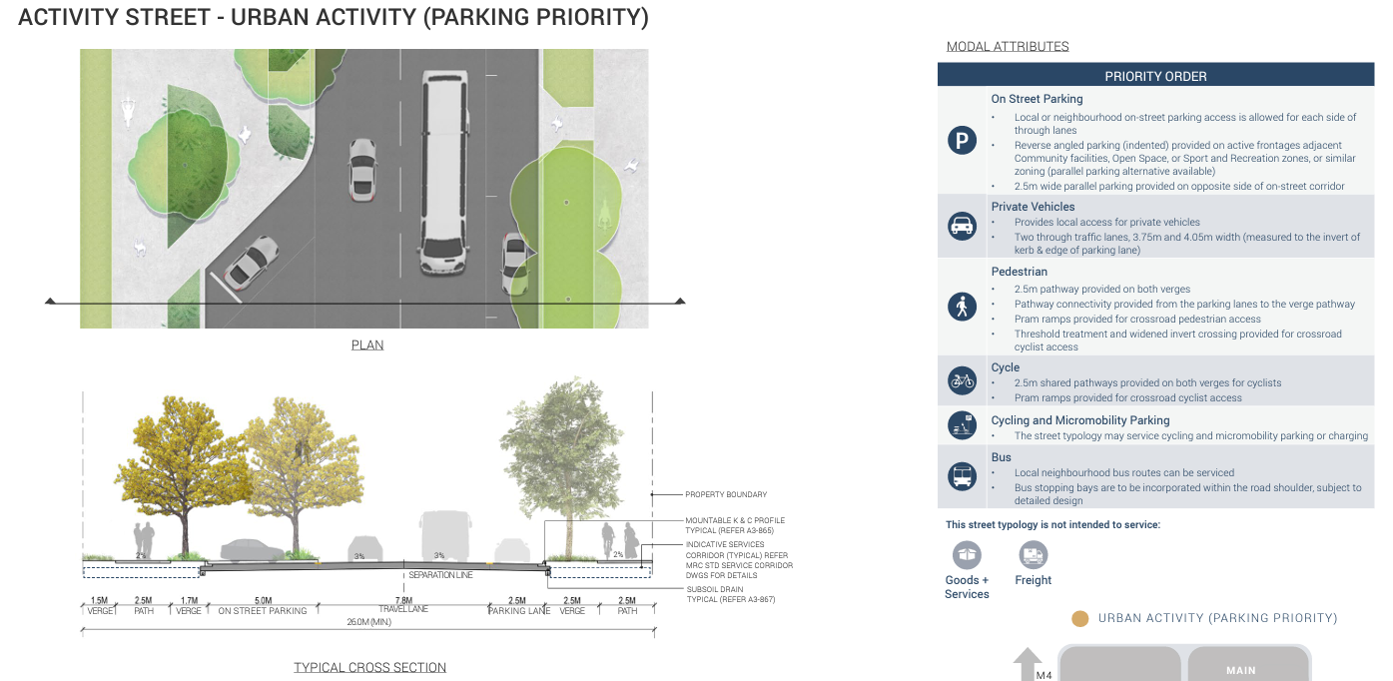

Link B & Link C
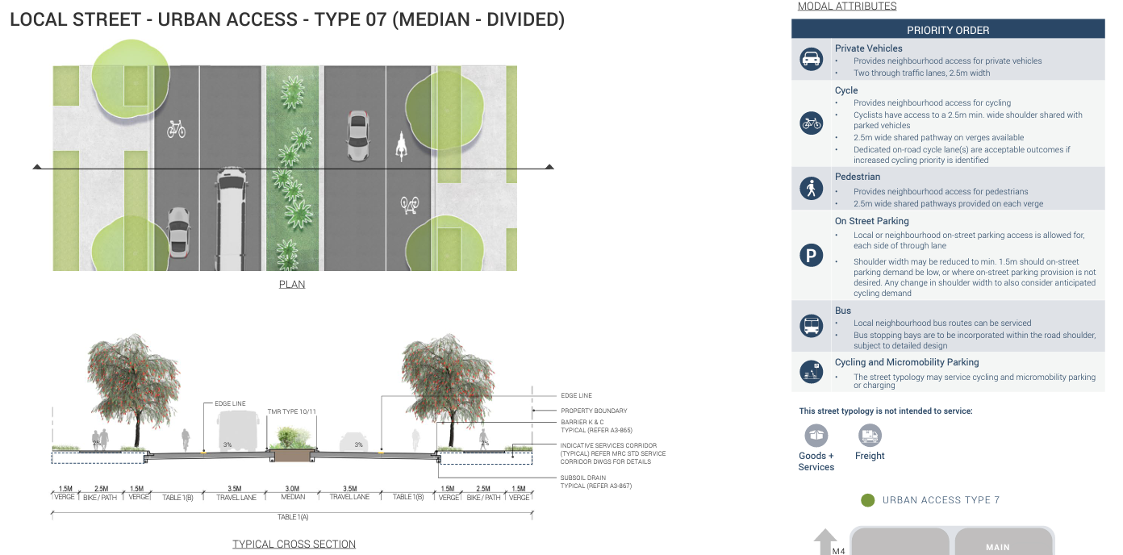

11. Summary
Each street now has a typical cross section design which reflects the movement, place, mode priority and design environment requirements of each.
This is summarised in the Movement and Place Framework Design Summary table below.

Street | PX | Function | MX | Modal Priority | PX/MX Possible Typologies | Adopted Typology | Adopted Reserve Width
Link A | P3 | Access | M2 | People walking, parking private vehicles, private vehicles, people cycling | Activity Street |  Urban Fringe Street | Activity Street – Urban Activity (Parking Priority) | 26.0m
Link B | P2 | Collector / Distributor | M2 | Private vehicles, parking private vehicles, Public Transport, People walking, People cycling | Local Street |  Urban Access  Type 06 | Urban Access Type 07 (median divided) | 26.0m
Link C | P1 | Distributor | M3 | People walking, private vehicles, people cycling, public transport | Urban Connector |  Distributor  Type 04

Movement & Place Framework Design Summary Table

12. Documentation
For any MCU, ROL or OW planning application, or any design project, the following documentation is required to demonstrate that appropriate Movement and Place design considerations have been undertaken:

The Movement and Place Framework Design Summary (MPFDS) table shall be completed and submitted as part of any relevant submission which involves the planning or design of a typology or road cross section. Refer Geometric Road Design PSP Error! Reference source not found.

The submission shall also include legible typical cross sections of each street showing which modal priority is serviced within the cross section (see Figure Error! No text of specified style in document.-4). Alternative documentation may be presented, so long as the relevant Movement and Place design considerations have been appropriately explored and demonstrated.

The submission of the MPFDS, or similar documentation, should reflect the nature and complexity of the accompanying planning application or proposed design.

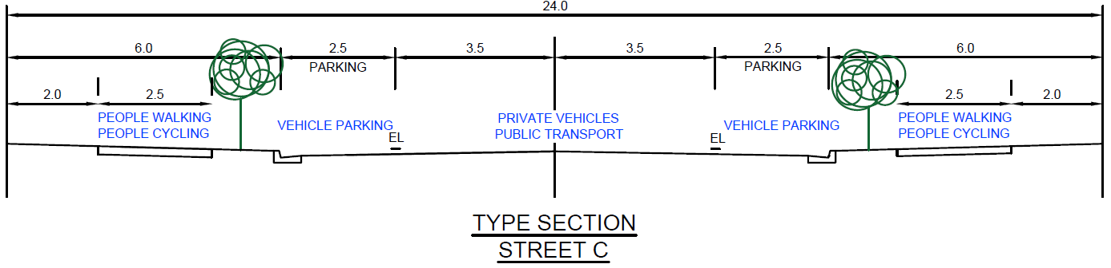
Figure Error! No text of specified style in document.-4: Example typical cross section/typology with transport mode details
The main role of the MPFDS, and supporting documentation, is to:

Ensure that the design responds to the Place value and the Council’s Planning Scheme Policies have been addressed

Demonstrate how the objectives of best practice design for Movement and Place have been applied and existing and future user needs have been incorporated

Show how access needs have been designed and are responsive to adjacent land uses

Provide for a legible typical cross section of the street and demonstrate how transport modes are catered for.
A suitably experienced practitioner or professional engineer (RPEQ) may endorse the applicable MPFDS submission, and any supporting documentation. The MPFDS is found in Error! Reference source not found..

